**BANK MANAGEMENT SYSTEM**

This bank management system project in C++ is a simple console application developed without the use of graphics components. It is more of a database project in C++, and is built using the language’s file handling mechanism. It is Basically run by employees suitable for those who want to add, edit, search, delete or modify records in a Bank.

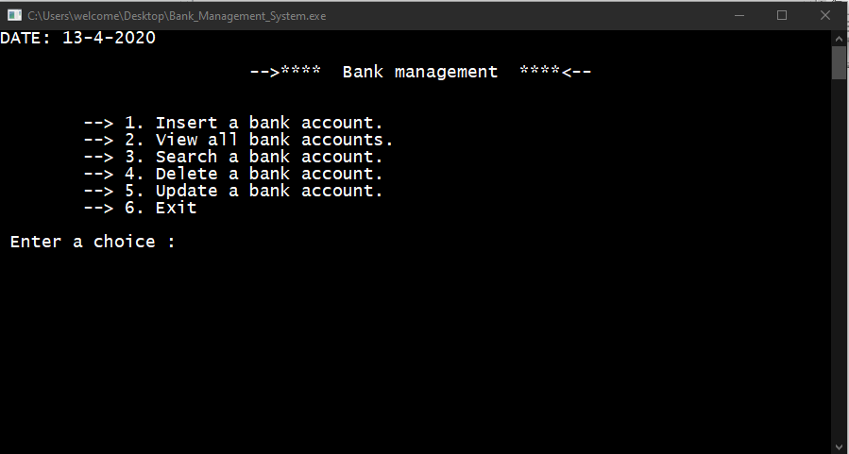

Here DATE Mention on the top of the Console Application will be Automatically Updated on bases of your system Date. To do any Operation: “PRESS NUMBER ACCORDINGLY”.

* **Add BANK ACCOUNT:**For add/create BANK ACCOUNT, Basically We have filled the Detail Such as Name of Account Holder and also his/her Date of Birth, Address, Contact Number, THEN.. Automatically ACCOUNT NUMBER will be GENERATED then you have to add 4 Digit Pin For SECURITY PURPOSES also we have to add some FIXED DEPOSIT AMOUNT.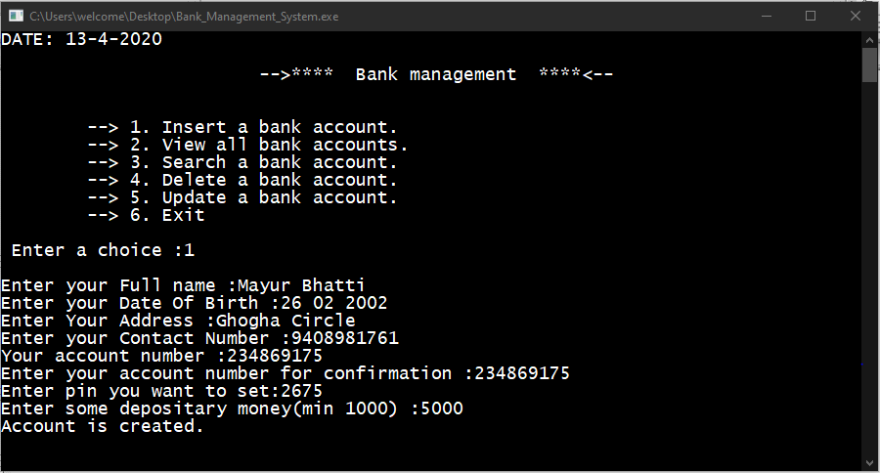
* **Show/List ALL BANK ACCOUNT:**With the information provided in Create ACCOUNT. We will get INFORMATION OF ALL ACCOUNT with sequence wise UPDATE with Name of Account Holder, Date Of Birth, Address, Contact Number, Account Balance BUT We will not show their ACCOUNT NUMBER And 4 DIGIT PIN so that Bank can’t able to ACCESS somebody Account Without OWNER Itself.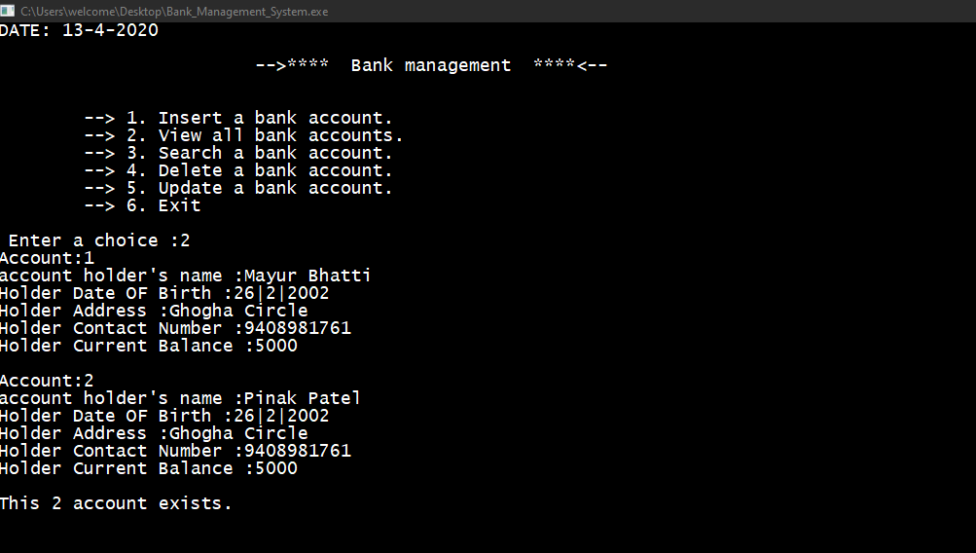
* **Search ACCOUNT:**When the function for this feature is first executed, We have to Add The SAME ACCOUNT NUMBER which was displays while Creating Account After that Enter 4 Digit Number So that all the Detail Will be DISPLAY. BUT If WE ADD WRONG ACCOUNT NUMBER THEN, displays the message – “Error..! Account Not Found” Also IF WE ADD WRONG PIN THEN, Display Message: “Enter YES or NO if you remember the pin:” IF YES then REWRITE PIN AGAIN Otherwise Message Display: “Sorry We cannot help you, Contact BANK HELP DESK.”

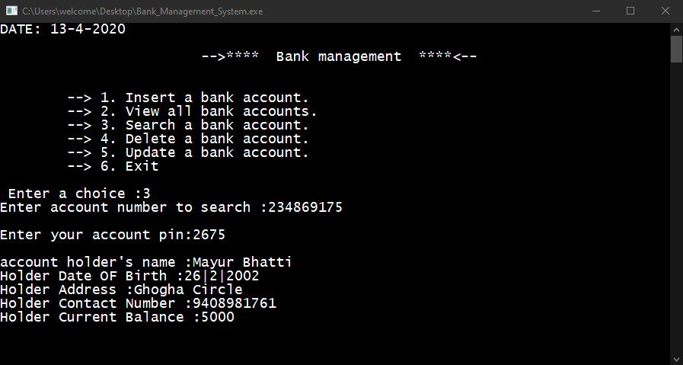

* **Update ACCOUNT:**This works in a similar manner to the Search feature. When the function for Edit Record is first executed, After ADD ACCOUNT NUMBER And PIN message will be Generated if We want to Change the Contact Number OR Address. IF YES THEN We can Change them OTHERWISE it will Display as its then We can add DEPOSITORY AMOUNT AND WITHDRAWAL AMOUNT, We can get CURRENT BALANCE Which will be UPDATED in YOUR ACCOUNT.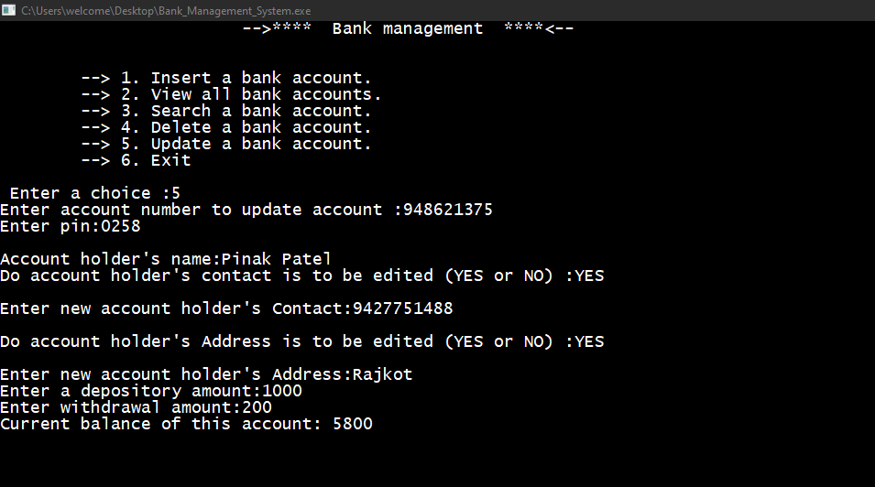

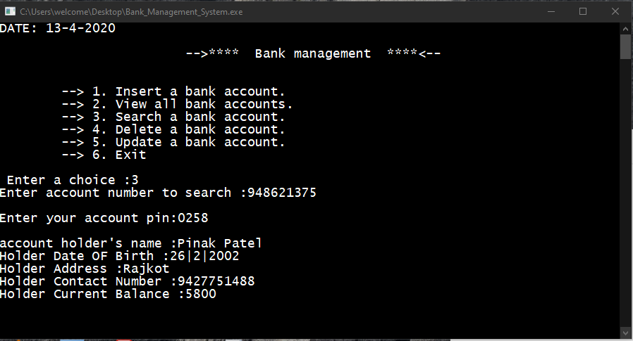

* **Delete ACCOUNT:**First of all, when the function of this feature is executed, After ADDING ACCOUNT NUMBER AND PIN. Message Display “Account is deleted & COLLECT your CASH FROM DESK”.

